**Homework 3**

**Points 100 (10 points per question)**

Note :- For all following problems, show your work and write the applicable paths and/or circuits. Only yes/no answers will not be accepted.

Q.1

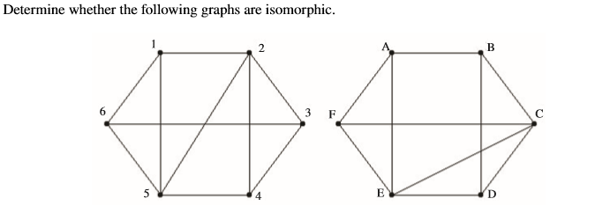

Q.2

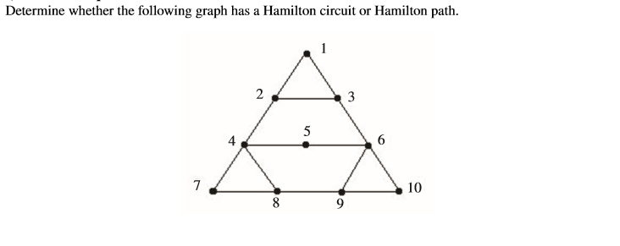

Q.3

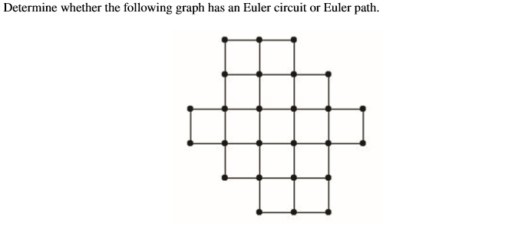

Q.4 Determine whether the following graph is bipartite.

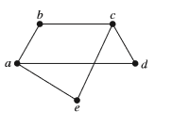

Q.5 Determine whether the following graph is bipartite.

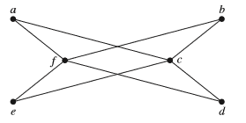

Q.6 For which values of n are these graphs bipartite?

a) Kn

b) Cn

Q.7 For which values of n are these graphs bipartite?

c) Wn

d) Qn

Q6. For which values of n are these graphs bipartite?

a) Kn:

For any value of n, the complete graph Kn is bipartite because we can divide the n vertices into two disjoint sets, such that there is no edge between any two vertices within the same set.

b) Cn:

The cycle graph Cn is bipartite if and only if n is even. We can divide the n vertices into two sets, one containing all the vertices with an even index and the other containing all the vertices with an odd index. Since every edge connects vertices with different parity, there can be no edge between vertices within the same set.

Q7. For which values of n are these graphs bipartite?

c) Wn:

The wheel graph Wn is bipartite if and only if n is even. We can divide the n vertices of the cycle into two sets, as we did in the case of Cn. Then, the hub vertex is in the opposite set from all other vertices, and hence every edge connects vertices with different parity.

d) Qn:

The hypercube graph Qn is bipartite for all n. We can represent each vertex of Qn by an n-bit binary string, where each bit is either 0 or 1. Then, we can divide the vertices into two sets based on the parity of their Hamming weight, which is the number of 1 bits in their binary representation. Since every edge connects vertices with different Hamming weight parity, there can be no edge between vertices within the same set.

Q.8 Find the union of the given pair of simple graphs.

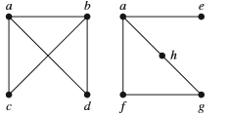

Q.9 Determine if the following graphs are isomorphic.

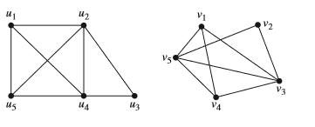

Q.10 Find the strongly connected components of following graph.

